Job Opportunity with Dr. Tom Roselle (’77)
Roselle Center for Healing — Fairfax, VA

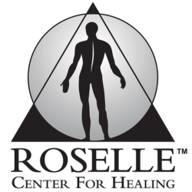
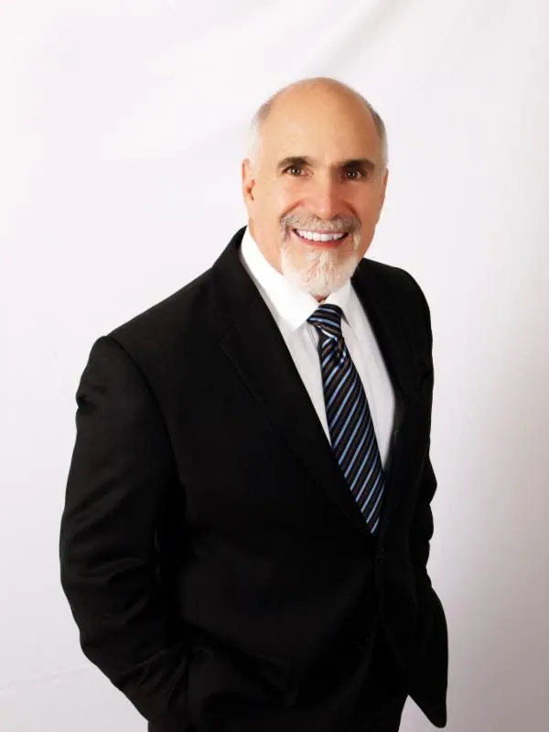
Are you a passionate and skilled chiropractor
ready to join a dynamic, multidisciplinary team?

The Roselle Center for Healing is seeking a motivated doctor who excels in manual adjusting, brings enthusiasm and energy to patient care, and enjoys collaborating with experienced chiropractors, acupuncturists, nutritionists and massage therapists.

Position Details
- Full-time: 37 Scheduled Contact Hours
- Compensation: $75K + Bonus Structure
- Benefits:
- 50% of Health Insurance Covered
- 401(k)
- Paid Time Off

📧 Interested candidates:
Contact Dr. Roselle at drtomroselle@gmail.com

🌐 Learn more: www.rosellecare.com

